Name – Davender Singh

Student ID – \*\*\*\*\*\*\*\*\*\*\*

Course – CCP555NSA

Professor – David Humphrey

1. Add all of the changes you've made to your code to git and push to GitHub. Link to the tests/integration folder on GitHub for your fragments repo, showing all of the .hurl files you wrote for the test cases above.

<https://github.com/davender-singh1/fragments/tree/main/tests/integration>

1. Screenshot of all three containers successfully being started using docker compose.

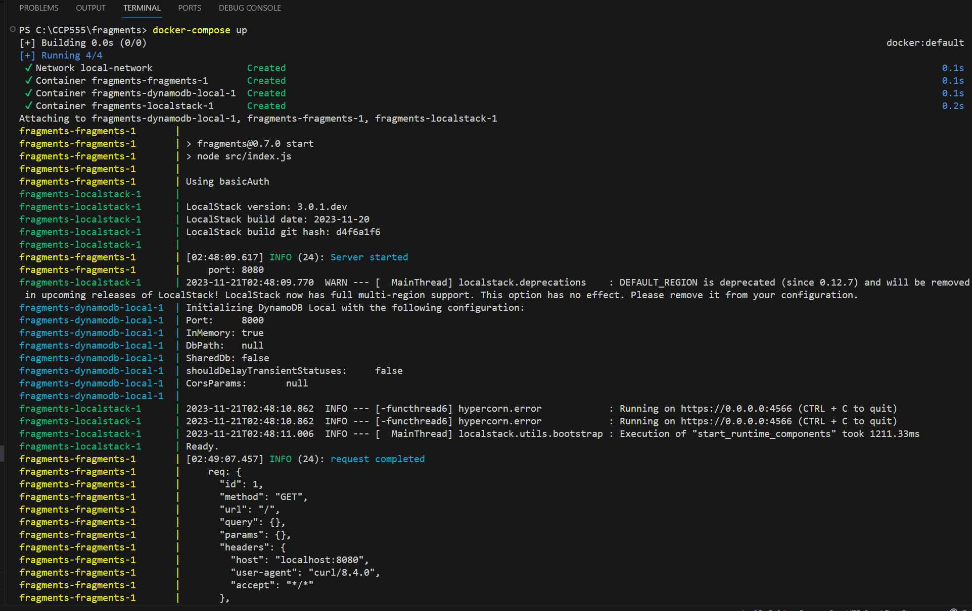

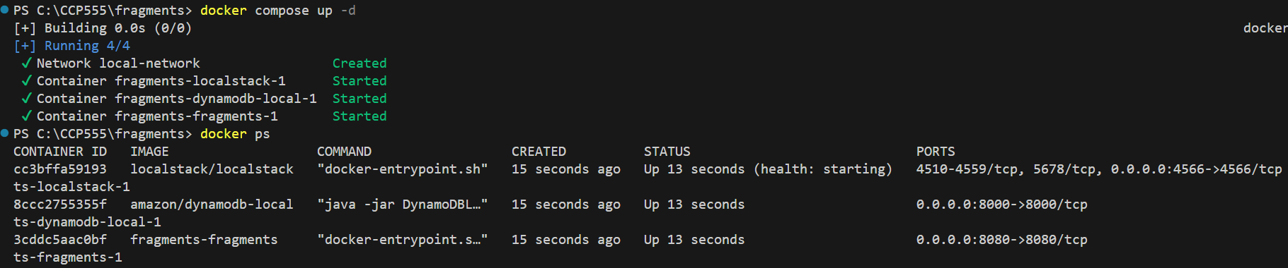

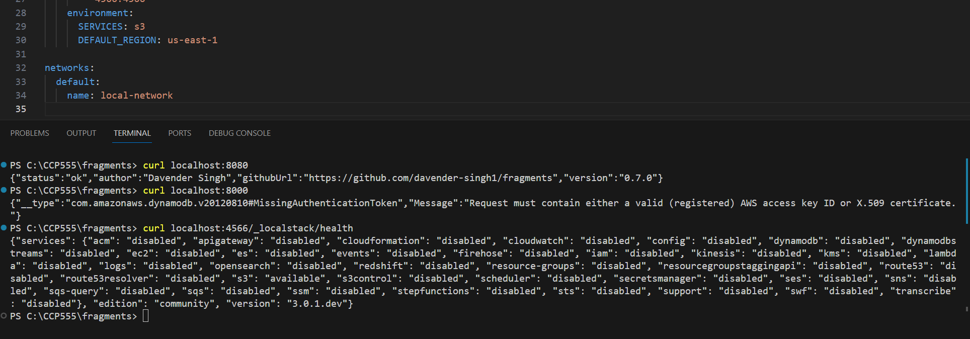

1. Screenshot of the local-aws-setup.sh running successfully against the running containers

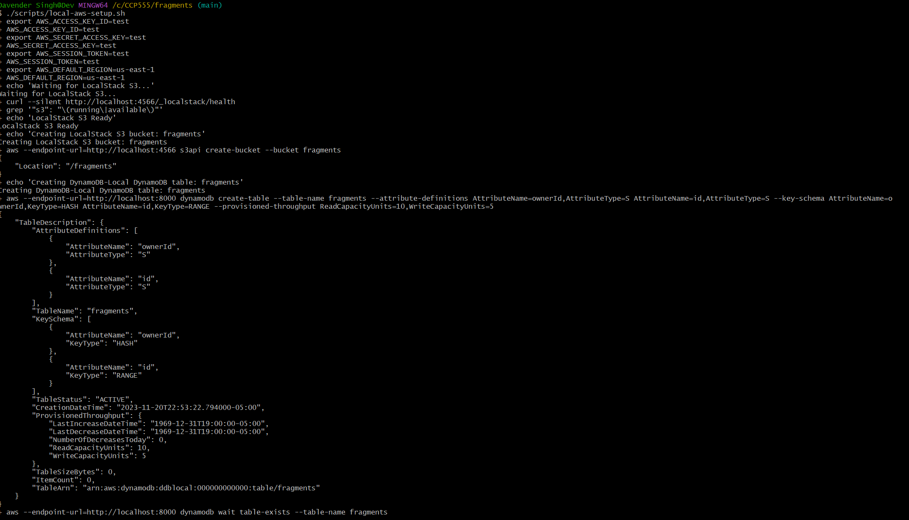

1. Screenshot of hurl successfully running all of the integration tests described above.

